
Semester Two
Examination, 2023
Question/Answer Booklet

HUMAN BIOLOGY
UNITS 1 & 2

Name: __________________________________________________________

Teacher: ______________________________________________________

Time allowed for this paper

Reading time before commencing work: ten minutes
Working time for the paper: two hours & thirty minutes

Materials required/recommended for this paper
To be provided by the supervisor
This Question/Answer Booklet
Multiple-choice Answer Sheet

To be provided by the candidate
Standard items: pens (blue/black preferred), pencils (including coloured), sharpener, correction fluid/tape, eraser, ruler, highlighters

Special items: up to three calculators, which do not have the capacity to create or store programmes or text, are permitted in this ATAR course examination

Important note to candidates
No other items may be taken into the examination room. It is your responsibility to ensure that you do not have any unauthorised material. If you have any unauthorised material with you, hand it to the supervisor before reading any further.
Structure of this paper

Section | Number of questions available | Number of questions to be answered | Suggested working time (minutes) | Marks available | Percentage of examination
Section One Multiple-choice | 25 | 25 | 30 | 25 | 30
Section Two Short answer | 7 | 7 | 80 | 90 | 50
Section Three Extended answer  Unit 1 | 2 | 1 | 40 | 15 | 20
Unit 2 | 2 | 1 |  | 20
 |  |  | Total | 150 | 100
Instructions to candidates

1. The rules for the conduct of the Western Australian examinations are detailed in the Year 12 Information Handbook 2022: Part II Examinations. Sitting this examination implies that you agree to abide by these rules.

2. Write your answers in this Question/Answer booklet preferably using a blue/black pen. Do not use erasable or gel pens.

3. Answer the questions according to the following instructions.

Section One: Answer all questions on the separate Multiple-choice answer sheet provided. For each question, shade the box to indicate your answer. Use only a blue or black pen to shade the boxes. Do not use erasable or gel pens. If you make a mistake, place a cross through that square, then shade your new answer. Do not erase or use correction fluid/tape. Marks will not be deducted for incorrect answers. No marks will be given if more than one answer is completed for any question.

Section Two: Write your answers in this Question/Answer booklet. Wherever possible, confine your answers to the line spaces provided.

Section Three: Consists of two parts each with two questions. You must answer one question from each part. Tick the box next to the question you are answering. Write your answers in this Question/Answer booklet

4. You must be careful to confine your answers to the specific questions asked and to follow any instructions that are specific to a particular question.

5. Supplementary pages for planning/continuing your answers to questions are provided at the end of this Question/Answer booklet. If you use these pages to continue an answer, indicate at the original answer where the answer is continued, i.e. give the page number.

Section One: Multiple–choice 30% (25 Marks)

This section has 25 questions. Answer all questions on the separate Multiple-choice answer sheet provided. For each question, shade the box to indicate your answer. Use only a blue or black pen to shade the boxes. Do not use erasable of gel pens. If you make a mistake, place a cross through that square, then shade your new answer. Do not erase or use correction fluid/tape. Marks will not be deducted for incorrect answers. No marks will be given if more than one answer is completed for any question.

Suggested working time: 30 minutes.

1. Which of the following components of blood plays an important role in protection against invading microorganisms?

(a) leucocytes
(b) erythrocytes
(c) plasma
(d) platelets

2. Which of the following is not a function of the lymphatic system?

(a) Carries excess tissue fluid that leaks out of cells.
(b) Carries leucocytes to aid in defence against disease.
(c) Contains lymph nodes for the production of erythrocytes.
(d) Empties fluid into large veins in the upper chest.

3. The platelets role in blood clotting is to

(a) form threads of insoluble protein called fibrin.
(b) release a fluid called serum.
(c) stick to the rough surface of the blood vessels.
(d) remove metabolic wastes from the clot.

4. Which of the following sexually transmitted infections (STIs) is caused by a virus?

(a) gonorrhoea
(b) chlamydia
(c) syphilis
(d) genital herpes

Questions 5 – 7 refer to the diagram below showing the structures within a human body cell.
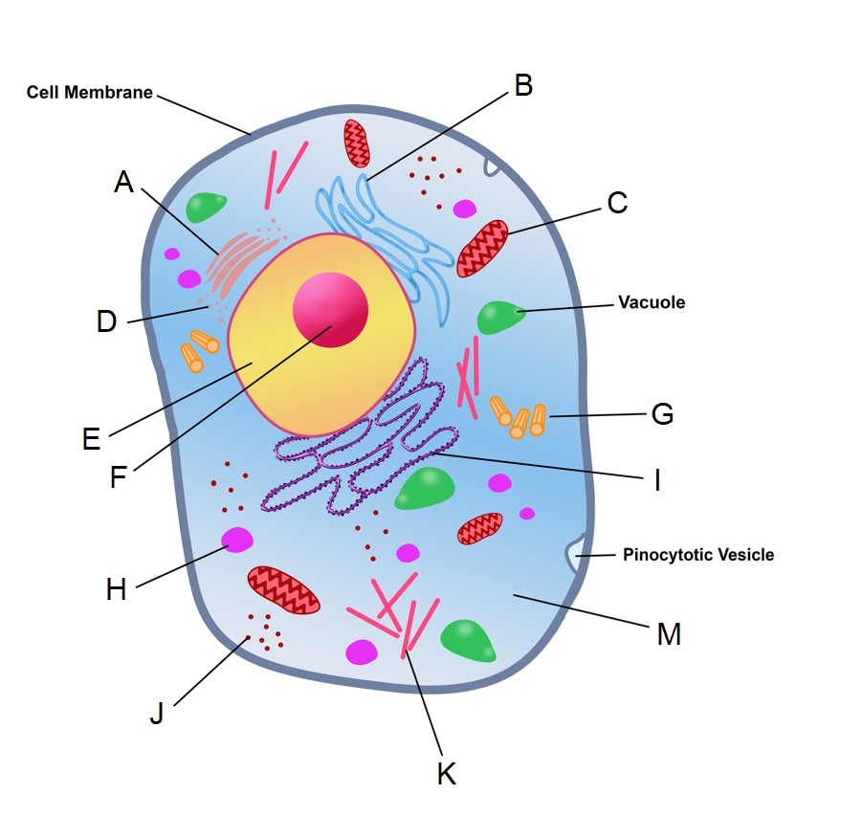

5. The structure labelled A is known as a

(a) Golgi apparatus.
(b) mitochondrion.
(c) centriole.
(d) microtubule.

6. The structures that form the spindle during mitosis and meiosis are indicated by which of the following labels?

(a) F
(b) J
(c) H
(d) G

7. Transcription takes place in which of the following parts?

(a) C
(b) E
(c) F
(d) M

8. The type of joint found where the humerus meets the ulna is best identified as a

(a) pivot joint.
(b) hinge joint.
(c) synovial joint.
(d) gliding joint.

9. Which of the following methods of contraception could be considered as a type of fertility awareness?

(a) the rhythm method
(b) coitus interruptus
(c) spermicides
(d) intrauterine devices

10. Which of the following structures is formed by the mesoderm during gestation?

(a) cartilage
(b) epithelium of the urinary bladder
(c) entire nervous system
(d) epidermis of the skin

11. A man with red-green colour blindness, a recessive condition caused by a mutated allele on the X chromosome, has children with a woman who is a carrier for the mutated allele. What is the probability they will have children with red-green colour blindness?

(a) 25%
(b) 50%
(c) 75%
(d) 100%

12. Fats, after digestion, are absorbed in the small intestine by

(a) simple diffusion into the blood capillaries.
(b) active transport into the blood capillaries.
(c) simple diffusion into the lacteals.
(d) active transport into the lacteals.

Questions 13 and 14 refer to the diagram below of a nephron.

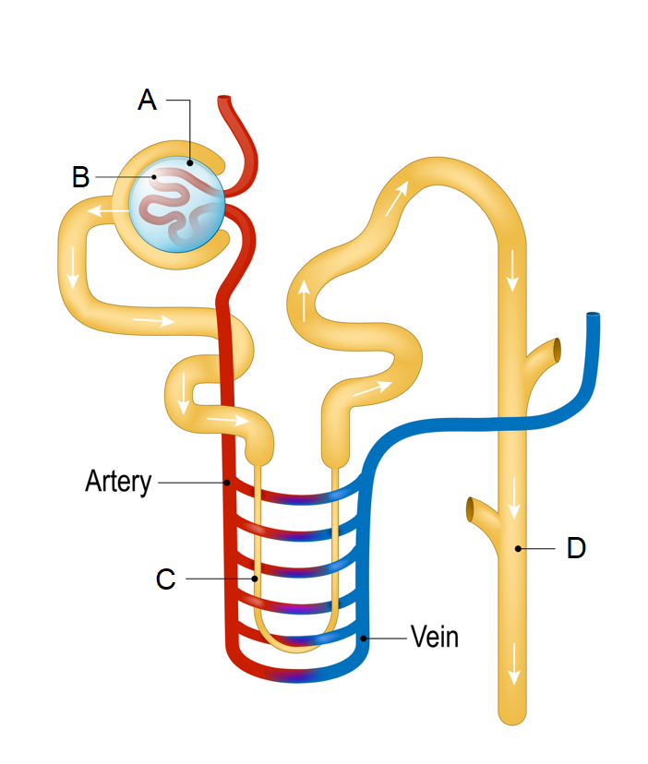

13. Which of the following processes occurs at the part labelled C?

(a) Active reabsorption of water.
(b) Secretion of hydrogen and potassium ions.
(c) Formation of filtrate.
(d) Passive reabsorption of water by osmosis.

14. Which of the following parts would have the highest concentration of glucose?

(a) A
(b) B
(c) C
(d) D

15. Mothers can help protect their unborn children from a condition called spina bifida by increasing their intake of which of the following nutrients during pregnancy?

(a) vitamin A
(b) calcium
(c) folic acid
(d) fluoride

16. The type of stem cells with the greatest level of potency are

(a) totipotent cells.
(b) pluripotent cells.
(c) multipotent cells.
(d) haemopoietic cells.

Questions 17 – 18 refer to the data shown in the table below.

Table 1: Activity of the digestive enzyme pepsin as a percentage of its maximum

pH | Activity of pepsin (%)
1.0 | 0
1.5 | 65
3.0 | 100
5.0 | 20
5.5 | 0

17. Which of the following could be considered a testable hypothesis for the experiment that generated this data?

(a) Pepsin works best in the stomach.
(b) The higher the pH, the greater the activity of pepsin.
(c) The activity of pepsin can be affected by pH levels.
(d) All digestive enzymes work best at a low pH.

18. This data could be transformed into a

(a) histogram.
(b) column graph.
(c) scatter plot.
(d) line graph.

19. The enzyme that is used to unwind DNA during DNA replication is known as

(a) DNA polymerase.
(b) RNA polymerase.
(c) DNA helicase.
(d) DNA ligase.

20. An increase in the concentration of a substrate in a chemical reaction

(a) will slow down the rate of reaction.
(b) will continually increase the rate of reaction.
(c) will initially increase rate of reaction until saturation occurs.
(d) will initially slow down rate of reaction until saturation occurs.

21. Which of the following correctly states the mode of inheritance for Huntington’s disease?

(a) X-linked, recessive
(b) autosomal, recessive
(c) X-linked, dominant
(d) autosomal, dominant

22. During inhalation

(a) the intercostal muscles relax, and pull the ribs up and out.
(b) the diaphragm relaxes, and increases the volume of the thoracic cavity.
(c) the intercostal muscles contract, and pull the ribs up and out.
(d) the diaphragm contracts, and decreases the volume of the thoracic cavity.

23. During menstruation, which of the following statements about hormones is correct?

(a) The levels of progesterone in the blood decrease, as the levels of FSH increase.
(b) The levels of progesterone in the blood increase, as the levels of FSH decrease.
(c) The levels of progesterone and FSH in the blood both increase.
(d) The levels of progesterone and FSH in the blood both decrease.

Questions 24 - 25 refer to the diagram below showing the digestive system.

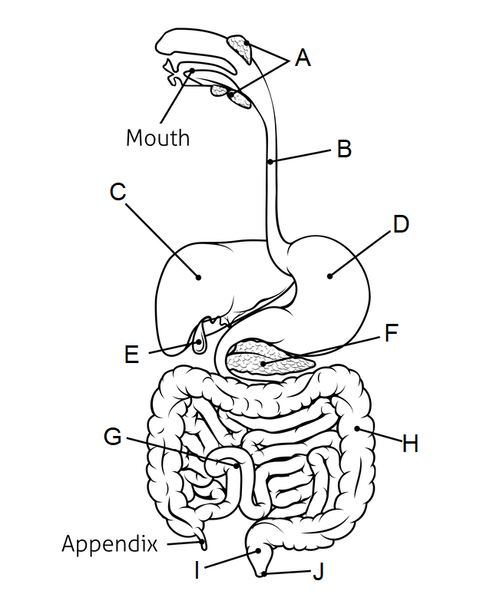

24. The part labelled F is the

(a) liver.
(b) stomach.
(c) pancreas.
(d) gall bladder.

25. Chemical digestion of proteins begins in

(a) the mouth.
(b) B.
(c) C.
(d) D.

End of Section One

Section Two: Short answer 50% (90 Marks)

This section has 7 questions. Answer all questions. Write your answers in the spaces provided.

Supplementary pages for planning/continuing your answers to questions are provided at the end of this Question/Answer booklet. If you use these pages to continue an answer, indicate at the original answer where the answer is continued, i.e. give the page number.

Suggested working time: 80 minutes.

Question 26 (15 marks)

Crohn’s disease is a disease that effects the alimentary canal, most commonly the small intestine and the upper part of the large intestine.

(a) Contrast the structure of the small and large intestine. (2 marks)

______________________________________________________________________

______________________________________________________________________

______________________________________________________________________

______________________________________________________________________

(b) During a flare up of Crohn’s the cells of the large intestinal wall may become inflamed and cannot function properly. Explain why this could lead to diarrhoea. (3 marks)

______________________________________________________________________

______________________________________________________________________

______________________________________________________________________

______________________________________________________________________

______________________________________________________________________

______________________________________________________________________

______________________________________________________________________

______________________________________________________________________

(c) One function of the large intestine is storing faeces for elimination from the body. Describe how elimination differs from the process of excretion. (2 marks)

______________________________________________________________________

______________________________________________________________________

______________________________________________________________________

______________________________________________________________________

Research into the cause of Crohn’s disease shows that it is a complex trait with an unclear pattern of inheritance, the best model suggests there is a major recessive allele that is responsible for a number of Crohn’s cases.

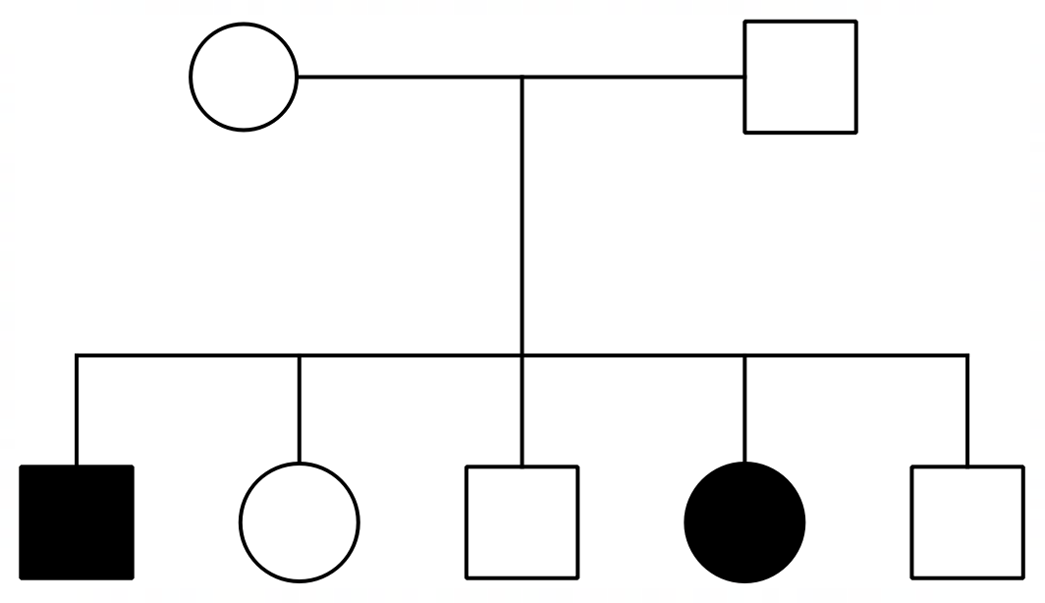The pedigree below shows the incidence of Crohn’s in a family, the shaded individuals have the disease.

(d) Explain, using evidence from the pedigree, why Crohn’s disease is autosomal and not X-linked. (3 marks)

______________________________________________________________________

______________________________________________________________________

______________________________________________________________________

______________________________________________________________________

______________________________________________________________________

______________________________________________________________________

(e) State the genotype, using the letters ‘N’ and ‘n’, for the parents of the two affected children. (1 mark)

______________________________________________________________________

(f) If a female with no history of Crohn’s in her family decides to have children with the affected male in generation II, what is the probability of their child having Crohn’s disease? Justify your answer with use of a Punnett square. (4 marks)

______________________________________________________________________

______________________________________________________________________

______________________________________________________________________

______________________________________________________________________

______________________________________________________________________

______________________________________________________________________

______________________________________________________________________

______________________________________________________________________

______________________________________________________________________

______________________________________________________________________

Question 27 (13 marks)

The diagram below shows the structure of the cell membrane and the role of a carrier protein in the transport of water across the membrane.

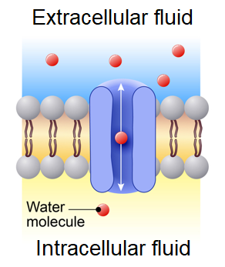

(a) On the diagram, label a phospholipid molecule, a hydrophilic head and hydrophobic tails. (3 marks)

(b) State whether the water molecules in the diagram will tend to move into the extracellular or intracellular fluid. (1 mark)

______________________________________________________________________

(c) Explain your answer to part (b) using your knowledge of osmosis. (3 marks)

______________________________________________________________________

______________________________________________________________________

______________________________________________________________________

______________________________________________________________________

______________________________________________________________________

______________________________________________________________________

______________________________________________________________________

(d) Explain why the water molecule cannot pass directly through the phospholipid bilayer.
(2 marks)

______________________________________________________________________

______________________________________________________________________

______________________________________________________________________

______________________________________________________________________

Proteins, such as the channel proteins in the diagram, are coded for by genes found in the nucleus of the cell. They are then built at the ribosomes in the cytoplasm of the cell in a process called translation.

(e) Describe the process of translation. (3 marks)

______________________________________________________________________

______________________________________________________________________

______________________________________________________________________

______________________________________________________________________

______________________________________________________________________

______________________________________________________________________

______________________________________________________________________

(f) Define epigenetics. (1 mark)

______________________________________________________________________

______________________________________________________________________

______________________________________________________________________

Question 28 (10 marks)

Osteoporosis is a bone disease that is characterised by a loss of bony matrix, leading to a reduction in minerals in the bone, and therefore bone density.

One test to determine whether or not a person is suffering from osteoporosis compares the bone density of a healthy 30-year-old to the bone density of the person being tested. This process involves a statistical analysis known as a T-score, which can be roughly converted into a percentage of bone loss in comparison to a healthy 30-year-old.

The table below shows the T-scores and percentage bone loss for different age groups of women.

Age group | T-score | *Bone loss (%)
50 – 55 | - 0.6 | 6
60 – 65 | - 1.2 | 12
70 – 75 | - 1.9 | 19
80 - 85 | - 2.5 | 25
* in comparison to a healthy 30-year-old female

(a) Construct a graph showing the bone loss, as a percentage, compared to age. (5 marks)

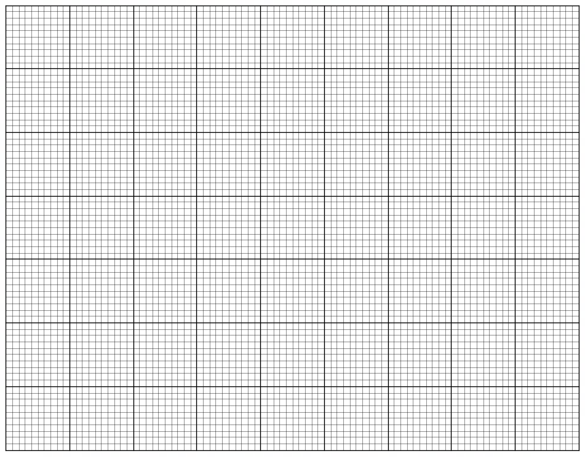

A spare grid is provided at the end of this Question/Answer Booklet. If you need to use it, cross
out this attempt and indicate that you have redrawn it on the spare grid.

(b) Describe the trend shown in the graph. (2 marks)

______________________________________________________________________

______________________________________________________________________

______________________________________________________________________

(c) Describe how sufferers of osteoporosis can manage/treat the condition and outline how this condition can be prevented. (3 marks)

______________________________________________________________________

______________________________________________________________________

______________________________________________________________________

______________________________________________________________________

______________________________________________________________________

______________________________________________________________________

______________________________________________________________________

Question 29 (11 marks)

The diagram below shows the processes of spermatogenesis and oogenesis.

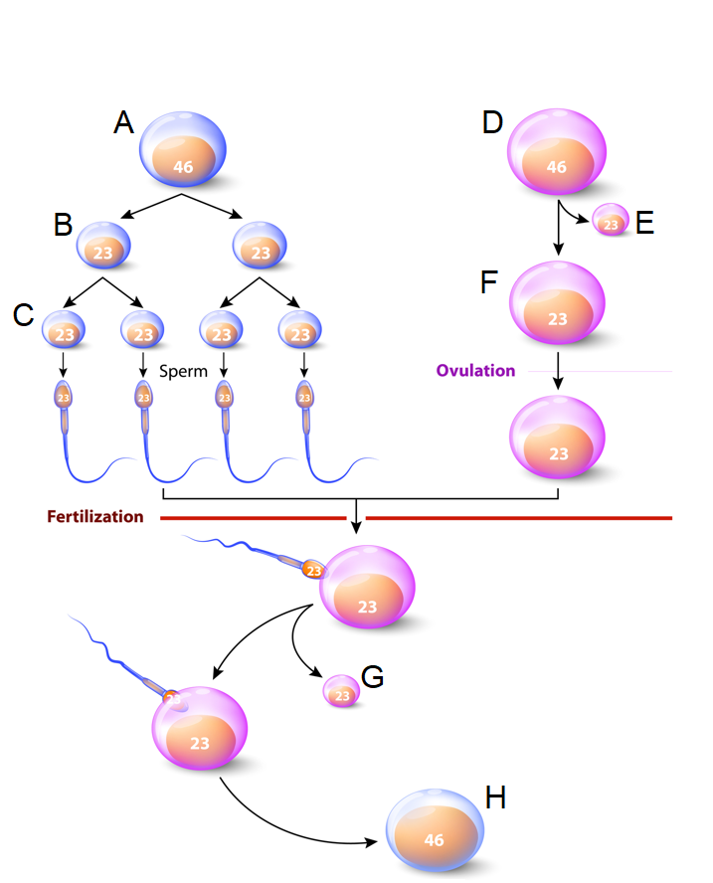

(a) Complete the table below, identifying the structures from the diagram above.
(3 marks)

Label | Name of structure
A
E
H

(b) Describe what ovulation refers to and name the hormone that triggers this process.
(2 marks)

______________________________________________________________________

______________________________________________________________________

______________________________________________________________________

(c) Explain how the structure of sperm suits their function. (4 marks)

______________________________________________________________________

______________________________________________________________________

______________________________________________________________________

______________________________________________________________________

______________________________________________________________________

______________________________________________________________________

______________________________________________________________________

______________________________________________________________________

______________________________________________________________________

______________________________________________________________________

(d) State two processes that occur during meiosis that can also lead to variation in the genotypes of offspring. (2 marks)

______________________________________________________________________

______________________________________________________________________

Question 30 (10 marks)

Blood transfusions can save lives, and is a helpful procedure for patients with severe infection, some types of blood disorders and when there is an extreme loss of blood due to accident or injury.

For cases involving extreme blood loss the goal of a blood transfusion is primarily linked to the replacement of erythrocytes.

(a) Describe the structure of erythrocytes. (2 marks)

______________________________________________________________________

______________________________________________________________________

______________________________________________________________________

______________________________________________________________________

(b) Describe the function of erythrocytes in the transport of gases. (3 marks)

______________________________________________________________________

______________________________________________________________________

______________________________________________________________________

______________________________________________________________________

______________________________________________________________________

______________________________________________________________________

______________________________________________________________________

______________________________________________________________________

(c) The ABO blood grouping system is based on inheritance through genetics and is determined by multiple alleles.

(i) Describe what is meant by a pattern of inheritance that is determined through multiple alleles. (1 mark)

________________________________________________________________

________________________________________________________________

(ii) Determine, with the use of a Punnett square, whether it is possible for two people with type A blood to have a child with type O. Include an explanation with your Punnett square. (4 marks)

________________________________________________________________

________________________________________________________________

________________________________________________________________

________________________________________________________________

________________________________________________________________

________________________________________________________________

________________________________________________________________

________________________________________________________________

________________________________________________________________

Question 31 (16 marks)

Skeletal muscles often work together to allow for articulation at a synovial joint, each type of muscle playing an important role in each differing movement.

(a) Describe what is meant by antagonistic pairs of muscles, using an example in the human body to aid your answer. (3 marks)

______________________________________________________________________

______________________________________________________________________

______________________________________________________________________

______________________________________________________________________

______________________________________________________________________

______________________________________________________________________

______________________________________________________________________

(b) Explain the importance of a fixator muscle when performing a particular movement at a synovial joint. (2 marks)

______________________________________________________________________

______________________________________________________________________

______________________________________________________________________

______________________________________________________________________

(c) Explain how the sliding filament theory allows for muscle contraction. (4 marks)

______________________________________________________________________

______________________________________________________________________

______________________________________________________________________

______________________________________________________________________

______________________________________________________________________

______________________________________________________________________

______________________________________________________________________

______________________________________________________________________

The diagram below shows the general structure of a synovial joint.

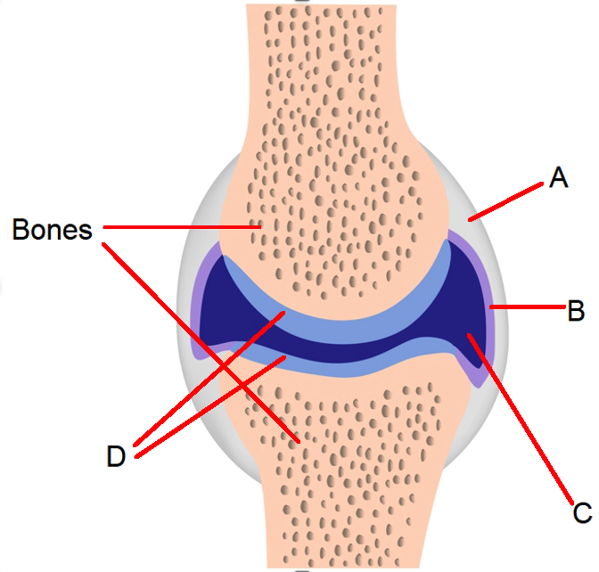

(d) Complete the table below, identifying the parts labelled in the diagram. (3 marks)

Label | Name
A
B
C

(e) Describe structure of type of cartilage labelled at point D. (1 mark)

______________________________________________________________________

______________________________________________________________________

(f) Name the condition that is characterised by the wearing away of the cartilage at a synovial joint and describe how this condition can be prevented and treated.
(3 marks)

______________________________________________________________________

______________________________________________________________________

______________________________________________________________________

______________________________________________________________________

______________________________________________________________________

______________________________________________________________________
Question 32 (15 marks)

The diagram below shows the structures of the human heart.

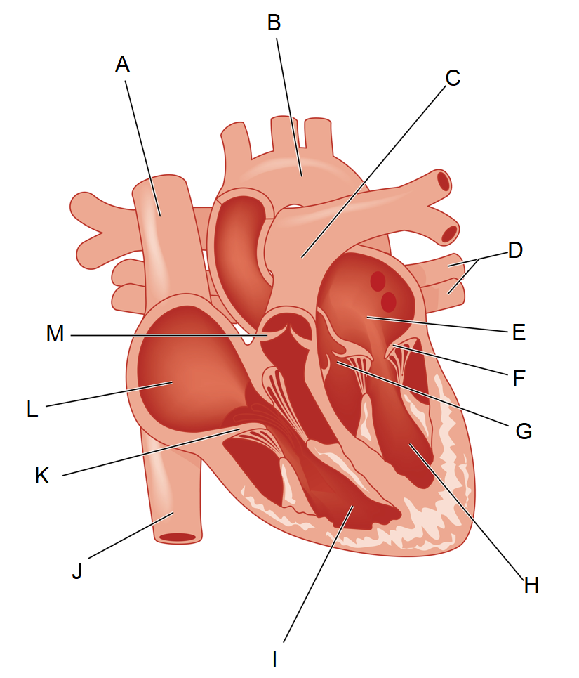

(a) Name the type of tissue that the heart is primarily comprised of, and describe the structure of this tissue. (3 marks)

______________________________________________________________________

______________________________________________________________________

______________________________________________________________________

______________________________________________________________________

(b) Complete the table below, describing the function of the parts labelled in the diagram.
(3 marks)
Label | Function
A
B
D

(c) Collectively outline the function and importance of the structures labelled F, G and K.
(3 marks)

______________________________________________________________________

______________________________________________________________________

______________________________________________________________________

______________________________________________________________________

______________________________________________________________________

During the foetal period of gestation the heart rate of the foetus can be monitored by a doctor or midwife. However, the foetus also relies on the connection with the mother through placenta and umbilical cord to aid in its circulatory system.

(d) Explain the role of the placenta and umbilical cord in aiding the circulatory system of the developing foetus. (4 marks)

______________________________________________________________________

______________________________________________________________________

______________________________________________________________________

______________________________________________________________________

______________________________________________________________________

______________________________________________________________________

______________________________________________________________________

______________________________________________________________________

(e) The placenta also releases hormones, including progesterone. Outline the role of progesterone in the menstrual cycle and suggest an explanation for why the placenta would secrete this hormone during pregnancy. (2 marks)

______________________________________________________________________

______________________________________________________________________

______________________________________________________________________

______________________________________________________________________

______________________________________________________________________

End of Section Two
Section Three: Extended answer 20% (35 Marks)

This section has four questions. You must answer two questions.

Questions 33 and 34 are from Unit 1. Questions 35 and 36 are from Unit 2. Answer one question from Unit 1 and one question from Unit 2.

Responses could include clearly labelled diagrams with explanatory notes; list of points with linking sentences; clearly labelled tables and graphs; and annotated flow diagrams with introductory notes.

Supplementary pages for planning/continuing your answers to questions are provided at the end of this Question/Answer booklet. If you use these pages to continue an answer, indicate at the original answer where the answer is continued, i.e. give the page number.

Suggested working time: 50 minutes.

Unit 1

Choose either Question 33 or Question 34.

Indicate the question you will answer by ticking the box next to the question. Write your answer on pages 27 - 31. When you have answered your first question, turn to page 32 and indicate on that page the second question you will answer.

Question 33 (15 marks)

Rhabdomyolysis is a condition where the muscle tissue is broken down and proteins enter the blood stream. This can lead to many complications, including an overproduction of urea and kidney failure.

(a) Describe the macroscopic and microscopic structure of skeletal muscle. (10 marks)

(b) Describe and explain the role of the liver in the overproduction of urea caused by the breakdown of proteins. (5 marks)

Question 34 (15 marks)

Cellular respiration is one of many essential metabolic processes that occurs in all cells.

(a) Contrast anaerobic and aerobic respiration. (8 marks)

(b) Explain how the functions of the digestive and circulatory system allow cellular respiration to take place in all cells in the body. (7 marks)

Question number: _______________

____________________________________________________________________________

____________________________________________________________________________

____________________________________________________________________________

____________________________________________________________________________

____________________________________________________________________________

____________________________________________________________________________

____________________________________________________________________________

____________________________________________________________________________

____________________________________________________________________________

____________________________________________________________________________

____________________________________________________________________________

____________________________________________________________________________

____________________________________________________________________________

____________________________________________________________________________

____________________________________________________________________________

____________________________________________________________________________

____________________________________________________________________________

____________________________________________________________________________

____________________________________________________________________________

____________________________________________________________________________

____________________________________________________________________________

____________________________________________________________________________

____________________________________________________________________________

____________________________________________________________________________

____________________________________________________________________________

____________________________________________________________________________
Question number: _______________

____________________________________________________________________________

____________________________________________________________________________

____________________________________________________________________________

____________________________________________________________________________

____________________________________________________________________________

____________________________________________________________________________

____________________________________________________________________________

____________________________________________________________________________

____________________________________________________________________________

____________________________________________________________________________

____________________________________________________________________________

____________________________________________________________________________

____________________________________________________________________________

____________________________________________________________________________

____________________________________________________________________________

____________________________________________________________________________

____________________________________________________________________________

____________________________________________________________________________

____________________________________________________________________________

____________________________________________________________________________

____________________________________________________________________________

____________________________________________________________________________

____________________________________________________________________________

____________________________________________________________________________

____________________________________________________________________________

____________________________________________________________________________
Question number: _______________

____________________________________________________________________________

____________________________________________________________________________

____________________________________________________________________________

____________________________________________________________________________

____________________________________________________________________________

____________________________________________________________________________

____________________________________________________________________________

____________________________________________________________________________

____________________________________________________________________________

____________________________________________________________________________

____________________________________________________________________________

____________________________________________________________________________

____________________________________________________________________________

____________________________________________________________________________

____________________________________________________________________________

____________________________________________________________________________

____________________________________________________________________________

____________________________________________________________________________

____________________________________________________________________________

____________________________________________________________________________

____________________________________________________________________________

____________________________________________________________________________

____________________________________________________________________________

____________________________________________________________________________

____________________________________________________________________________

____________________________________________________________________________
Question number: _______________

____________________________________________________________________________

____________________________________________________________________________

____________________________________________________________________________

____________________________________________________________________________

____________________________________________________________________________

____________________________________________________________________________

____________________________________________________________________________

____________________________________________________________________________

____________________________________________________________________________

____________________________________________________________________________

____________________________________________________________________________

____________________________________________________________________________

____________________________________________________________________________

____________________________________________________________________________

____________________________________________________________________________

____________________________________________________________________________

____________________________________________________________________________

____________________________________________________________________________

____________________________________________________________________________

____________________________________________________________________________

____________________________________________________________________________

____________________________________________________________________________

____________________________________________________________________________

____________________________________________________________________________

____________________________________________________________________________

____________________________________________________________________________
Question number: _______________

____________________________________________________________________________

____________________________________________________________________________

____________________________________________________________________________

____________________________________________________________________________

____________________________________________________________________________

____________________________________________________________________________

____________________________________________________________________________

____________________________________________________________________________

____________________________________________________________________________

____________________________________________________________________________

____________________________________________________________________________

____________________________________________________________________________

____________________________________________________________________________

____________________________________________________________________________

____________________________________________________________________________

____________________________________________________________________________

____________________________________________________________________________

____________________________________________________________________________

____________________________________________________________________________

____________________________________________________________________________

____________________________________________________________________________

____________________________________________________________________________

____________________________________________________________________________

____________________________________________________________________________

____________________________________________________________________________

____________________________________________________________________________
Unit 2

Choose either Question 35 or Question 36.

Indicate the question you will answer by ticking the box next to the question. Write your answer on the pages provided.

Question 35 (20 marks)

The production of identical daughter cells through the process of mitosis allows for growth, repair and replacement of tissues throughout our lifetime.

(a) Name and describe the four phases of mitosis. (12 marks)

(b) Describe what is meant by the term cancer and explain how the development of malignant tumours can be detrimental to the functioning of normal body tissues.
(5 marks)

(c) Describe how cervical screening tests, breast screening and blood tests have made early detections of some cancers possible. (3 marks)

Question 36 (20 marks)

After 10 months of trying to fall pregnant a couple were able to determine the establishment of a successful pregnancy through a standard pregnancy test for levels of human chorionic gonadotropin.

(a) Outline the path of the sperm from the epididymis to the point where conception occurs. Include in your answer a description of the process of fertilisation.
(10 marks)

The couple were informed by a health professional that they were in a high-risk category for genetic and physical abnormalities in their unborn child. They were advised to undergo a series of tests.

(b) Describe how the following allow for screening of the embryo or foetus during early development: (10 marks)
- Blood test (of the mother’s blood)
- Ultrasound
- Amniocentesis

End of questions
Question number: _______________

____________________________________________________________________________

____________________________________________________________________________

____________________________________________________________________________

____________________________________________________________________________

____________________________________________________________________________

____________________________________________________________________________

____________________________________________________________________________

____________________________________________________________________________

____________________________________________________________________________

____________________________________________________________________________

____________________________________________________________________________

____________________________________________________________________________

____________________________________________________________________________

____________________________________________________________________________

____________________________________________________________________________

____________________________________________________________________________

____________________________________________________________________________

____________________________________________________________________________

____________________________________________________________________________

____________________________________________________________________________

____________________________________________________________________________

____________________________________________________________________________

____________________________________________________________________________

____________________________________________________________________________

____________________________________________________________________________

____________________________________________________________________________
Question number: _______________

____________________________________________________________________________

____________________________________________________________________________

____________________________________________________________________________

____________________________________________________________________________

____________________________________________________________________________

____________________________________________________________________________

____________________________________________________________________________

____________________________________________________________________________

____________________________________________________________________________

____________________________________________________________________________

____________________________________________________________________________

____________________________________________________________________________

____________________________________________________________________________

____________________________________________________________________________

____________________________________________________________________________

____________________________________________________________________________

____________________________________________________________________________

____________________________________________________________________________

____________________________________________________________________________

____________________________________________________________________________

____________________________________________________________________________

____________________________________________________________________________

____________________________________________________________________________

____________________________________________________________________________

____________________________________________________________________________

____________________________________________________________________________
Question number: _______________

____________________________________________________________________________

____________________________________________________________________________

____________________________________________________________________________

____________________________________________________________________________

____________________________________________________________________________

____________________________________________________________________________

____________________________________________________________________________

____________________________________________________________________________

____________________________________________________________________________

____________________________________________________________________________

____________________________________________________________________________

____________________________________________________________________________

____________________________________________________________________________

____________________________________________________________________________

____________________________________________________________________________

____________________________________________________________________________

____________________________________________________________________________

____________________________________________________________________________

____________________________________________________________________________

____________________________________________________________________________

____________________________________________________________________________

____________________________________________________________________________

____________________________________________________________________________

____________________________________________________________________________

____________________________________________________________________________

____________________________________________________________________________
Question number: _______________

____________________________________________________________________________

____________________________________________________________________________

____________________________________________________________________________

____________________________________________________________________________

____________________________________________________________________________

____________________________________________________________________________

____________________________________________________________________________

____________________________________________________________________________

____________________________________________________________________________

____________________________________________________________________________

____________________________________________________________________________

____________________________________________________________________________

____________________________________________________________________________

____________________________________________________________________________

____________________________________________________________________________

____________________________________________________________________________

____________________________________________________________________________

____________________________________________________________________________

____________________________________________________________________________

____________________________________________________________________________

____________________________________________________________________________

____________________________________________________________________________

____________________________________________________________________________

____________________________________________________________________________

____________________________________________________________________________

____________________________________________________________________________
Question number: _______________

____________________________________________________________________________

____________________________________________________________________________

____________________________________________________________________________

____________________________________________________________________________

____________________________________________________________________________

____________________________________________________________________________

____________________________________________________________________________

____________________________________________________________________________

____________________________________________________________________________

____________________________________________________________________________

____________________________________________________________________________

____________________________________________________________________________

____________________________________________________________________________

____________________________________________________________________________

____________________________________________________________________________

____________________________________________________________________________

____________________________________________________________________________

____________________________________________________________________________

____________________________________________________________________________

____________________________________________________________________________

____________________________________________________________________________

____________________________________________________________________________

____________________________________________________________________________

____________________________________________________________________________

____________________________________________________________________________

____________________________________________________________________________
Supplementary page

Question number: _______________

____________________________________________________________________________

____________________________________________________________________________

____________________________________________________________________________

____________________________________________________________________________

____________________________________________________________________________

____________________________________________________________________________

____________________________________________________________________________

____________________________________________________________________________

____________________________________________________________________________

____________________________________________________________________________

____________________________________________________________________________

____________________________________________________________________________

____________________________________________________________________________

____________________________________________________________________________

____________________________________________________________________________

____________________________________________________________________________

____________________________________________________________________________

____________________________________________________________________________

____________________________________________________________________________

____________________________________________________________________________

____________________________________________________________________________

____________________________________________________________________________

____________________________________________________________________________

____________________________________________________________________________

____________________________________________________________________________
Supplementary page

Question number: _______________

____________________________________________________________________________

____________________________________________________________________________

____________________________________________________________________________

____________________________________________________________________________

____________________________________________________________________________

____________________________________________________________________________

____________________________________________________________________________

____________________________________________________________________________

____________________________________________________________________________

____________________________________________________________________________

____________________________________________________________________________

____________________________________________________________________________

____________________________________________________________________________

____________________________________________________________________________

____________________________________________________________________________

____________________________________________________________________________

____________________________________________________________________________

____________________________________________________________________________

____________________________________________________________________________

____________________________________________________________________________

____________________________________________________________________________

____________________________________________________________________________

____________________________________________________________________________

____________________________________________________________________________

____________________________________________________________________________
Supplementary page

Question number: _______________

____________________________________________________________________________

____________________________________________________________________________

____________________________________________________________________________

____________________________________________________________________________

____________________________________________________________________________

____________________________________________________________________________

____________________________________________________________________________

____________________________________________________________________________

____________________________________________________________________________

____________________________________________________________________________

____________________________________________________________________________

____________________________________________________________________________

____________________________________________________________________________

____________________________________________________________________________

____________________________________________________________________________

____________________________________________________________________________

____________________________________________________________________________

____________________________________________________________________________

____________________________________________________________________________

____________________________________________________________________________

____________________________________________________________________________

____________________________________________________________________________

____________________________________________________________________________

____________________________________________________________________________

____________________________________________________________________________
Supplementary page

Question number: _______________

____________________________________________________________________________

____________________________________________________________________________

____________________________________________________________________________

____________________________________________________________________________

____________________________________________________________________________

____________________________________________________________________________

____________________________________________________________________________

____________________________________________________________________________

____________________________________________________________________________

____________________________________________________________________________

____________________________________________________________________________

____________________________________________________________________________

____________________________________________________________________________

____________________________________________________________________________

____________________________________________________________________________

____________________________________________________________________________

____________________________________________________________________________

____________________________________________________________________________

____________________________________________________________________________

____________________________________________________________________________

____________________________________________________________________________

____________________________________________________________________________

____________________________________________________________________________

____________________________________________________________________________

___________________________________________________________________________

Spare grid



ACKNOWLEDGEMENTS

Question 5 – 7 Adapted from: Radu, B. (n.d) [Animal cell diagram]. Retrieved from https://www.dreamstime.com/stock-illustration-animal-cell-structure-white-background-vector-illustration-helpful-education-schools-image65486924

Questions 14 – 15 Adapted from: Designua (n.d.) [Structure of a Nephron diagram]. Retrieved from https://www.dreamstime.com/structure-nephron-formation-urine-liquid-enters-to-glomerulus-browman-s-capsule-goes-down-loop-henle-collecting-image102564238

Question 28 – 30 Adapted from: Georghiou, C. (n.d.) [Digestive Tract System Illustration]. Retrieved from https://www.dreamstime.com/stock-illustration-digestive-tract-system-illustration-human-alimentary-canal-labels-black-white-image84348384

Question 32 Adapted from: Designua (n.d.) [Mechanisms for the transport of ions and molecules across cell diagram]. Retrieved from https://www.dreamstime.com/stock-illustration-mechanisms-transport-ions-molecules-across-cell-m-membranes-types-channel-membrane-simple-diffusion-image77366193

Question 34 Adapted from: Desginua (n.d.) [Spermatogenesis and Oogenesis diagram]. Retrieved from https://www.dreamstime.com/stock-illustration-spermatogenesis-oogenesis-ovogenesis-creation-ovum-female-form-gametogenesis-male-image53839558#_

Question 36 Adapted from: Alila07 (n.d.) [Synovial joint structure diagram]. Retrieved from: https://www.dreamstime.com/stock-images-synovial-joint-structure-image22042874

Question 37 Adapted from: Legger (n.d.) [The heart diagram]. Retrieved from: https://www.dreamstime.com/stock-illustration-heart-cross-section-showing-major-vessels-named-valves-created-adobe-illustrator-contains-gradient-meshes-image54204327

